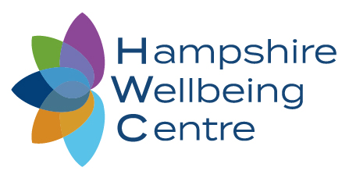
Face to Face or Virtual Consultation Decision Making
During Coronavirus Pandemic
At the Hampshire Wellbeing Centre the safety of each and every one of our clients, their families, and our staff has always been our number one priority. In line with Government advice, and information from our own Professional body, we ceased offering face to face consultations on 27th March 2020 and moved our physiotherapy service completely to video conferencing. We have since been conducting around 20-30 of these each week and have had excellent feedback for those using this service. To help prevent the spread of coronavirus we will continue to offer such consultations as our first choice intervention for the foreseeable future.
However, as the restrictions ease, we are able to offer some face to face Physiotherapy sessions but we must be able to justify the benefit of such a session when balanced against the risk of unwittingly spreading the coronavirus.
The below flow chart will help you to understand whether your appointment should be virtual, face to face, or a combination of both.
Coronavirus Pandemic Physiotherapy Consultation Pathway
Client Enquiry / GP or Specialist referral / Insurance referral
Intervention via video or telephone consultation and patient managed as such until discharge or clinical situation changes
Patient attends the clinic in accordance with our current clinic visitor’s policy (see separate content)
Agreed clinical decision that the patient requires a face to face consultation. Risk versus benefits discussed and patient’s consent to attend given.

Free of charge telephone triage
Acute problem WITH concerning features, or post-operative physiotherapy, or worsening symptoms that have failed to improve with virtual care
Agreed clinical decision to manage client via video or phone consultation
Acute problem with NO concerning features, or recurrent chronic issue

